MSFT Data Science Interview

Eugene’s Modeling Test

William Constantine, Ph.D.

**E-Mail**: [wlbconstan@gmail.com](mailto:wlbconstan@gmail.com)

**Phone**: (253) 324-8738

**GitHub Project URL**: https://github.com/wconstan/msft-office-sample.git

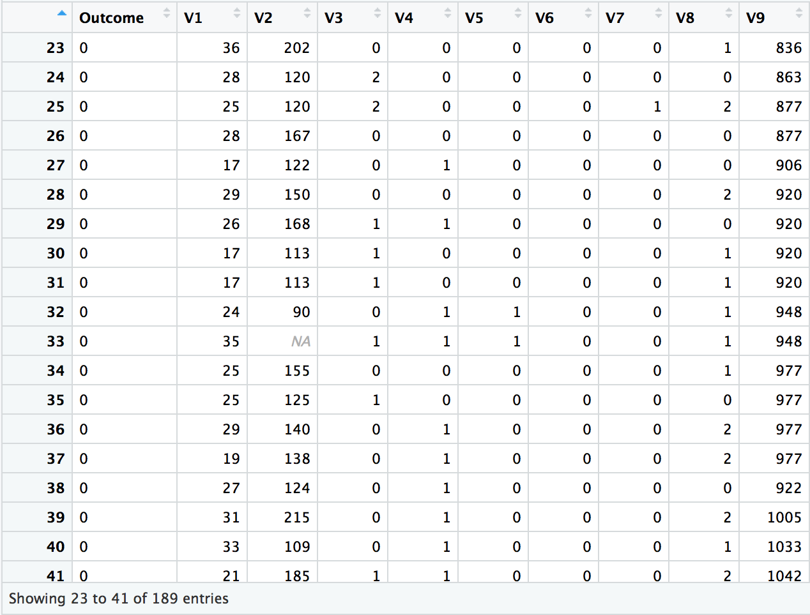

# Objective

Dr. Chudin supplied a small data set with an identified dependent variable (Outcome) and nine predictor variables (V1, …, V9). The objective was to build a model for predicting the Outcome variable using the predictors and to discuss conclusions.

# Scripting Language

I chose the R language to develop the models for this exercise as there are many advanced statistical and machine learning packages freely available and it is easy to generate good looking plots to explain the results. The R script I created is attached to this report. You can also clone a GitHub repository that I created for this project to obtain the source: https://github.com/wconstan/msft-office-sample.git.

# Data Considerations

## Class Imbalance

The data has a sizable class imbalance with Outcome=0 having more than twice the number of observations labeled as Outcome=1:

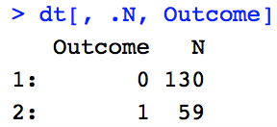

Most machine learning classifiers are sensitive to an imbalance in the predictors used for training the model. Generally, an unbalanced dataset will bias the prediction model towards the more common class. There are two main techniques used for balancing data:

* **under-sampling**: a random subset of observations is taken from the class with more samples to match the lesser number of samples available in other classes. The main disadvantage of under-sampling is that we lose potentially relevant information from the omitted samples.
* **oversampling**: samples are duplicated from the class with fewer instances or are based on the data that we have, so as to match the number of samples in each class. The risk in this approach is contaminating both the test and training data sets with oversampled values, which may lead to overfitting and an overestimation of our model’s performance and generalizability.

There are also hybrid approaches that involve a mix of over- and under-sampling. For the current study, I compare the classification results for the following approaches:

1. do nothing (not appealing)
2. under-sampling
3. over-sampling
4. [ROSE](https://journal.r-project.org/archive/2014/RJ-2014-008/RJ-2014-008.pdf): A Package for Binary Imbalanced Learning
5. [SMOTE](https://arxiv.org/pdf/1106.1813.pdf): Synthetic Minority Over-sampling Technique

## Missing Data

There is only a single value that is missing in the data: observation 33 of the V2 predictor. I used rfImpute(Outcome ~ ., dt) to fill in the missing point, where dt is the data frame containing all supplied observations. rfImpute works by first replacing NA values with corresponding column medians and then feeding the resulting data set into a random forest model. The proximity matrix from the random forest is used to update the imputation of the NA values, which is taken as the weighted average of the non-missing observations where the weights are the proximities. As V2 was originally comprised of integer values, I coerced the resulting imputation to type integer as well.

# Classification Models

## Variable Correlations

The first step in the modeling process began with and visual examination of variable correlation through a pairs plot with color-coded classes (Fig. 1). The data was standardized in this plot for easier visual comparison. I observed in the final row of the pairs plot that the classes seemed *perfectly* divided over *all* paired variables with an appropriate value of V9 to split the data. A visualization of one of these pairs and the resulting perfect split is shown in Fig. 2. Based on this observation, I manually split the data into two sets based on the split rule V9 >= -0.578 and assessed the classification error based solely on predicting the **majority** class for each group. This emulates what would be done by a decision tree at the first node in the tree. In this case, the parent node (original data) had a classification error of 0.31 while the classification error of the two children after the split was **zero**! Seemingly, our work is done. However, our model would not be very robust if the data outside of the training set was much different than the small dataset that we were given for training our model and it would be wise to actually assume this to be the case.



Figure 1: Pairs plot of imputed data



Figure 2: Split on standardized data at V9=-0.578 illustrates a perfect division of the classes in the V1-V9 space

## Introducing Noise

To make our model more generalizable, I generated noisy versions (y) of the dominant V9 variable by adding Gaussian noise ($ϵ$)

$$y=v9+ ϵ$$

such that resulting data had a specified signal-to-noise ratio, defined to be

$$SNR≡ \frac{σ_{V9}^{2}}{σ_{ϵ}^{2}}$$

where $σ_{x}$ is the (sample) standard deviation of x. Figures 3 shows a comparison of the final row of the pairs plot for three different levels of additive noise: none, SNR=2, and SNR=1. As the noise level increases, you can see that the separation of classes is less defined, making a simple single cut of the data at a particular threshold less effective.

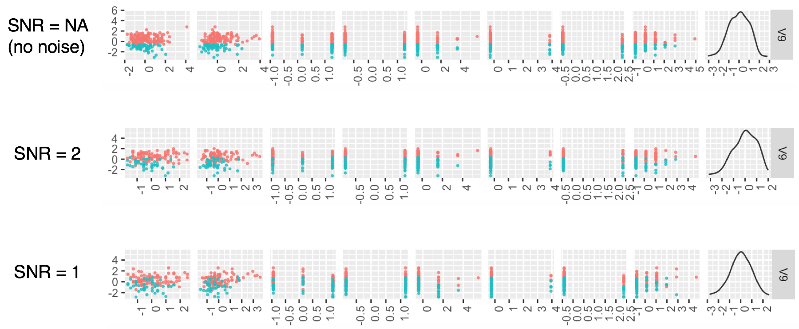

Figure 3: Pairs plots for V9 with different levels of additive noise

This experiment seems a bit restrictive: why not add noise to other variables? How can we assume that V9 observations outside of the supplied training data will be noisy at all? The point of this limited experiment is to emulate what conditions *may* exist outside of the training data and to make our model more robust to those potential differences. I chose to manipulate only the V9 variable as it is dominates the other variables by importance, at least according to a random forest model using the original data:

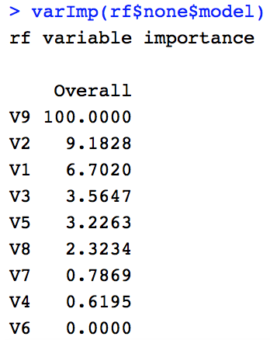

## Modeling Approach

I developed both *random forest* and *logistic regression* binary classification models using the **caret** package. Logistic regression was chosen as it is a staple classifier for binary outcomes, modeling the log-odds as a weighted sum of the explanatory variables. Random forest was chosen because tree-based classifiers are easy to understand and based on clear evidence presented above that we have data that does well to isolate classes using splits of the original data. The randomness of random forest involves training multiple trees using data that is sampled both by taking a certain percentage of the rows (observations) but also the columns (predictors). That means that the (important) V9 feature may be excluded in some of the trees that are grown, forcing these tree-models to rely on other features in the data. The ensemble effect of averaging over many trees is intended to help prevent overfitting and increase generalizability.

We have a very small data set and so the traditional split of the data in *training*, *validation*, and *test* sets is not recommended. We **always** should create out a test set and I have done so using a 70/30 split of the original data. Instead of additionally splitting the remaining 70% into both training and validation sets, however, we invoke the use of k-fold cross validation, which is illustrated in Fig. 4 (taken from <https://www.kaggle.com/dansbecker/cross-validation>). The basic idea is to take advantage of *all* of the remaining data by running experiments with different holdout sets used for validation and keeping the rest for training. Running all of the experiments ensures that you have used all of the data at some point to validate your models. Generally, cross-validation gives a more accurate measure of model quality but comes at the cost of larger/high computational burden. Since our data set is quite small, the computational burden is low and we can ignore this detriment.

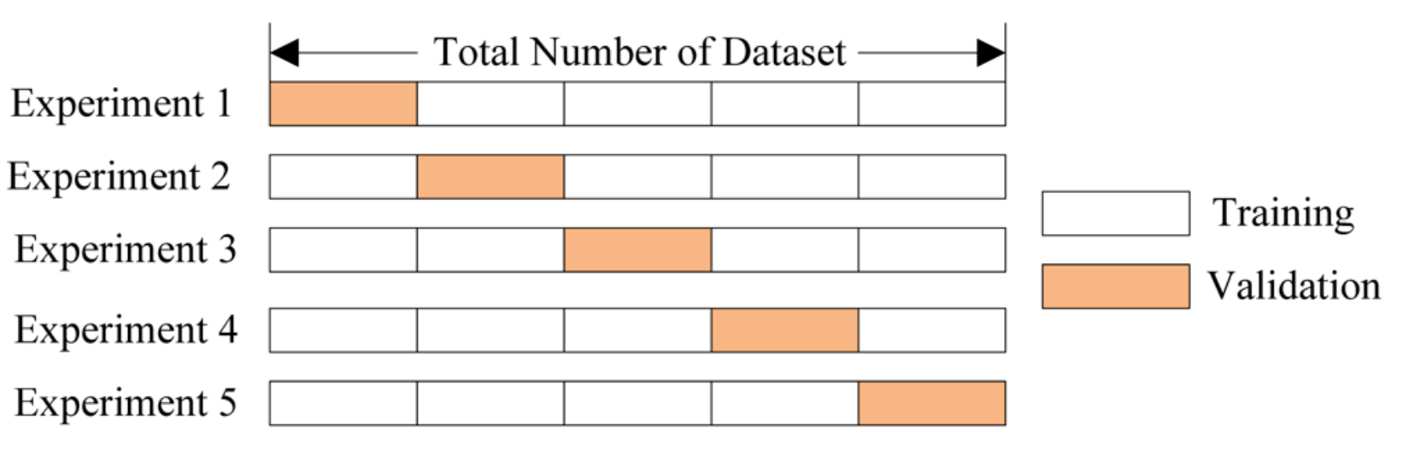

Figure 4: k-fold partitioning of data for cross validation

Note that we still have a class imbalance to consider given that we our training and test sets are stratified by class:

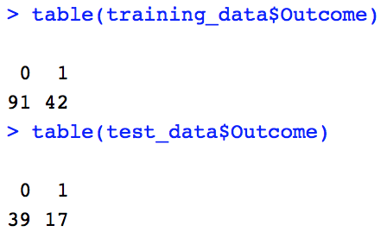

The imbalance in the training data was addressed using the five methods: *none*, *under-sampling*, *oversampling*, *ROSE*, and *SMOTE*. These are easily configured in the **caret** package via an optional **sampling** parameter in the trainControl functional. Each model was run using a 10-fold cross validation repeated 5 times and the following performance metrics gathered for each model: *sensitivity*, *specificity*, *precision*, *recall*, *F1*, and *balanced* *accuracy*. The repeats just ensure that the data is split in different ways.

## Model Performance

Figure 4 shows a summary of the model performances faceted by sampling mode (used to counter class imbalance) and V9 SNR value (intended to make the models more robust to noise). While the results of the SNR=NA (original data) row look stellar, I would suggest that they should not to be trusted given a likely lack of generalizability. I have more confidence in the generalizability of models where we added noise. Of particular interest is the {rose, SNR=1} result, which demonstrates an *overall* better performance relative to other combinations at the SNR=1 level. The random forest model does quite a bit better than the logistic regression model in the {rose, SNR=1} group and would be the model I would choose as the “optimal” model for scoring new data, relative to the other models tested.



Figure 5: Model performance summary

# Conclusions

There are always other models to try: support vector machines, neural nets, etc. But I think I captured the essence of the modeling exercise and identified and explored the following issues:

* missing data: imputation to fill missing gaps
* class imbalance: use sampling techniques
* small data set: invoke k-fold cross validation on remaining training data after training/test split
* model generalizability: models rarely (if ever) are capable of obtaining *perfect* performance in the real-world. By adding noise to the V9 data, we allow our models to be more flexible and robust to noise contamination that likely exists in real-world data.
* visual inspection: rather than blindly feeding the data into a classifier, I took the time to explore the pairwise correlation and density/distribution of variables. It was here that I gained insight into a potential issue involving generalizability.